**EMPLOYEE MANAGEMENT SYSTEM**

A Mini-Project Report

Submitted for the partial fulfillment for the award of degree of

**MASTER OF SCIENCE IN COMPUTER SCIENCE**

Submitted by

**K.PAZHANISAMY** (**Reg No**: A20MCS08)

Under the Guidance of

**Dr . A . VICTORIA ANAND MARY M.C.A., M.Phil., B.Ed., SET, Ph.D.,**

Assistant Professor, (Post Graduate and Research Department of Computer Science)



**ST.JOSEPH’S COLLEGE OF ARTS & SCIENCE(AUTONOMOUS)**

(Affiliated to Thiruvalluvar University-Vellore)

**CUDDALORE- 607001**

**November –2021**

**CERTIFICATE**

This is to certify that the Mini-Project entitled

**EMPLOYEE MANAGEMENT SYSTEM**

Being submitted to

St. Joseph’s College of Arts and Science (Autonomous),

(Affiliated to Thiruvalluvar University – Vellore)

By

**K.PAZHANISAMY** (**Reg No**: A20MCS08)

For the partial Fulfillment for the award of degree of

**MASTER OF SCIENCE IN COMPUTER SCIENCE**

Is a Bonafide record of work carried out by him,

Under My guidance and supervision.

**Internal Guide Head of the Department**

Submitted for the viva-voce examination on ______________________________

**Examiners:**

1.

2.

**ACKNOWLEDGEMENT**

It is my earnest and sincere desire and ambition to acquire profound knowledge in the study of Masters in Computer Science. I am grateful to God, the Almighty who has blessed me abundantly and guided me to complete this task.

I express my sincere thanks to most respectful Secretary, **Rev.Fr.G.PETER RAJENDIRAM., M.A., M.Sc.,M.Ed. M.Phil.,** St. Joseph’s College of Arts and Science (Autonomous), Cuddalore, for providing such a good congenial environment to enlighten my knowledge.

I thank **Dr.M.ARUMAI SELVAM M.Sc.,(Maths).,M.Sc.(CS).,M.Phil(CS).,** Principal and Head Department of computer science, for his moral support.

I take immense pleasure in conveying my sincere and deepest gratitude to my internal guide

**Dr . A . VICTORIA ANAND MARY M.C.A., M.Phil., B.Ed., SET, Ph.D.,** Assistant Professor, Post Graduate and Research Department of Computer Science, for her valuable guidance, inspiration, consent and motivation throughout the development of the project.

At the Outset, I extend my sincere gratitude to all our Staff of Computer Science for having rendered all Support whenever needed.

I will fail in our duty if I do not put on record my heartfelt gratitude to my beloved parents for their financial and material support as well their words of encouragement and motivation to complete this project successfully.

Last but not the Least, I place my deepest sense of gratitude to all my friends who had inspired and supported me to complete this project more successfully.

K.PAZHANISAMY

**TABLE OF CONTENT**

|  |  |  |
| --- | --- | --- |
| **S. NO** | **CONTENT** | **PAGE. NO** |
| 1. | **ABSTRACT**  **INTRODUCTION** | 1  2 |
| 2. | **SYSTEM ANALYSIS**  2.1 EXISTING SYSTEM  2.2 DRAWBACKS OF EXISTING SYSTEM  2.3 PROPOSED SYSTEM  2.4 FEASIBILITY STUDY  2.4.1 TECHNICAL FEASIBILITY  2.4.2 OPERATIONAL FEASIBILITY  2.5 ALTERNATIVE SOLUTION | 3 |
| 3. | **SYSTEM SPECIFICATION**  3.1 HARDWARE REQUIREMENTS  3.2 SOFTWARE REQUIREMENTS | 5 |
| 4. | **SOFTWARE DESCRIPTION**  4.1 FRONT END-PHP  4.2 PHP FEATURES  4.3 BACK END MY-SQL SERVER  4.4 MY SQL-SERVER FEATURES | 6 |
| 5. | **PROJECT DESCRIPTION**  5.1 MODULES  5.2 MODULES DESCRIPTION  5.2.1 GENERAL ENTRY  5.2.2 ADMIN ENTRY  5.2.3 EMPLOYEE ENTRY  5.3 DATA FLOW DIAGRAM  5.3.1 ARCHITECTURE  5.3.2 SEQUENCE DIAGRAM  5.3.3 ACTIVITY DIAGRAM  5.4 DATABASE DESIGN | 12 |
| 6. | **SYSTEM TESTING**  6.1 UNIT TESTING  6.2 ACCEPTANCE TESTING  6.3 TEST CASES | 19 |
| 7. | **CONCLUSION & FUTURE ENHANCEMENTS**  7.1 CONCLUSION  7.2 FUTURE ENHANCEMENTS | 20 |
| 8. | **APPENDIX**  8.1 SCREENSHOTS  8.2 SAMPLE SOURCE CODE | 21 |

**ABSTRACT**

The mini project titled “EMPLOYEE MANAGEMENT SYSTEM” is designed to computerized the employee details of an organization or a company. The project is developed with “PHP” as the front end and “MYSQL” as the backend. The text editor Subline Text Editor is used with coding language “PHP”. The Employee Management System will automate the operations performed over the information of an employee. This computerization will help in many instances and reduce the workload of company as most of the manual work done is reduced. The project will store the personal and official details of an employee like employee name, employee id, contact details, address, salary, project details and leave.

This Project developed by using “PHP” as a Server side scripting and “MySQL” as a database server.

**CHAPTER 1**

**INTRODUCTION**

* 1. **ABOUT THE PROJECT**

The Project “EMPLOYEE MANAGEMENT SYSTEM” is an unofficial try to make a record system for company to store the employee details . The employee management system stores Various details of the employee like Name, Contact details, e-mail id, Address. This project is an eye opener to promote online employee management .

**NEED FOR THE PROJECT**

The following are the essential needs for making this website:

1. During this covid19 pandemic situation few companies are closed and many companies have established work from home scenario .
2. To maintain and handle all details of the employees of an company easily and also access the record from anywhere and anytime .
3. To promote an automated system to manage the employee details and encourage the user to access the website easily and to manage things more efficiently.

To help employee to avoid manual work and reduce workload . This online employee management system is more useful to the work from home employees enabling them to utilize the online features avaliable.

**CHAPTER 2**

**SYSTEM ANALYSIS**

**2.1 EXISTING SYSTEM**

As per the details collected from employee of the company , various records were analysed and the existing system was proposed to have the following drawbacks associated with them. They are:

1. No online employee record management for the company is maintained. They are records manually done.
2. No interface between employee and administrator to know proper information about employees in a company .
3. Lack of awareness among the employee of an company to ensure their information maintained in the company database is accurate or not.
4. Employee gives hand written leave letter and wait for the administrator response and permission.

**2.2 DRAWBACKS OF EXISTING SYSTEM**

Based on the data and information gathered from all the source

* There is no automated system to store employee records
* Consume more time, space, workload and maintaining the records is difficult

**2.3 PROPOSED SYSTEM**

* The analysis is made with the existing system and its pitfalls and a proposed system is made. A proposal is made for developing a full automated system.
* They are fast.
* They will not interface with the other traffic as they require separate underground infrastructure

**2.4 FEASIBILITY STUDY**

The system to be developed must be developed in such a way that it overwhelms the pitfalls identified in the previous system. So, to be more effective, the feasibility study is made.There are various types of feasibility studies carried out for the efficiency of the system. Two of them are very important in the initial stages of the project.

**2.4.1 TECHNICAL FEASIBILITY**

Technical part of a project is as important as it is going to matter much after automating the system. The software needs to be developed in the right platform with the right software. This technical compatibility alone marks the true success of the project and stands as the difference between the manual and automated system. After careful analysis, the proposal is made to implement the project as a website online.

**2.4.2 OPERATIONAL FEASIBILITY**

The Operational part both access and view level decides the output of the project and also the satisfaction of the user who uses the system. The Operational feasibility helps the project to develop user friendly features in the website and can support the development of website in an efficient manner.

**2.5 ALTERNATIVE SOLUTION**

* Alternative solutions also should be considered in order to merit the selected solution for the existing problem.
* It could be developed using any Rapid Application Development tool, so that development time is reduced.
* It could have been developed using Web Builder also, but there are drawbacks if we use them and moreover the organization has already many products developed using Asp.net technology.
* It’s comfortable for the organization if the project is developed in the XAMPP Server back-end page.
* We can know about the tender reports easily through online. We can also know about the tender types.
* We also can know about the updated information and contractor information.
* The data dictionary is used to collect inter relational data type, data.
* Name and data size of the table. It is mainly used for designing the table.

**CHAPTER 3**

**SYSTEM SPECIFICATION**

**HARDWARE REQUIREMENTS**

|  |  |
| --- | --- |
| HARDWARE | SPECIFICATION |
| MONITOR | 17 “ INCHES |
| KEYBOARD | NUMERIC OR MULTIMEDIA |
| HARDDISK | MIN 500 MB |
| MOUSE | OPTICAL OR NORMAL |
| RAM | 1 GB OR MORE |

**SOFTWARE REQUIREMENTS**

|  |  |
| --- | --- |
| COMPONENT | SOFTWARE & TOOLS |
| FRONTEND | HTML5, CSS 3 |
| SERVER-SIDE SCRIPTING | PHP 8.0.2 |
| CLIENT SIDE SCRIPTING | JAVASCRIPT, AJAX |
| BACKEND | MY SQL 5.0.4 |
| EXECUTION SERVER | XAMPP SERVER 8.0.2 |
| IMAGE & VIDEO | PICSART 18.3.2, KINEMASTER 5.2.2 |
| DESIGNING TOOLS | SUBLIME TEXT EDITOR 3.0 |
| BROWSERS | GOOGLE CHROME |

**CHAPTER 4**

**SOFTWARE DESCRIPTION**

**4.1 FRONT END-SUBLIME TEXT EDITOR**

**INTRODUCTION TO SUBLIME TEXT EDITOR**

**Sublime Text** is a [shareware](https://en.wikipedia.org/wiki/Shareware) [cross-platform](https://en.wikipedia.org/wiki/Cross-platform) [source code editor](https://en.wikipedia.org/wiki/Source_code_editor) with a [Python](https://en.wikipedia.org/wiki/Python_(programming_language)) [application programming interface](https://en.wikipedia.org/wiki/Application_programming_interface) (API). It natively supports many [programming languages](https://en.wikipedia.org/wiki/Programming_languages) and [markup languages](https://en.wikipedia.org/wiki/Markup_languages), and functions can be added by users with [plugins](https://en.wikipedia.org/wiki/Plugins), typically community-built and maintained under [free-software licenses](https://en.wikipedia.org/wiki/Free_software_licenses).

**SUBLIME TEXT EDITOR**

* "Go to Anything," quick navigation to files, symbols, or lines
* "Command palette" uses adaptive matching for quick keyboard invocation of arbitrary commands
* [Simultaneous editing](https://en.wikipedia.org/wiki/Simultaneous_editing): simultaneously make the same interactive changes to multiple selected areas
* Python-based plugin API
* Project-specific preferences
* Extensive customizability via JSON settings files, including project-specific and platform-specific settings
* Cross-platform (Windows, [macOS](https://en.wikipedia.org/wiki/MacOS), and Linux) and Supportive Plugins for cross-platform
* Compatible with many language grammars from [Text Mate](https://en.wikipedia.org/wiki/TextMate)

**4.2 SUBLIME TEXT FEATURES**

Dreamweaver, like other HTML editors, edits files locally then uploads them to the remote web server using FTP, SFTP, or Web DAV. Dreamweaver CS4 now supports the Subversion (SVN) version control system.

* Action Script
* Active Server Pages (ASP).
* C#
* Cascading Style Sheets (CSS)
* ColdFusion
* EDML
* Extensible Hypertext Markup Language (XHTML)
* Extensible Markup Language (XML)
* Extensible Stylesheet Language Transformations (XSLT)
* Hypertext Markup Language (HTML)
* Java
* JavaScript
* PHP
* Visual Basic (VB)
* Visual Basic Script Edition (VBScript)
* Wireless Markup Language (WML)

Support for Active Server Pages (ASP) and JavaServer Pages was dropped in version CS5.

Users can add their own language syntax highlighting. In addition, code completion is available for many of these languages.

**OVERVIEW OF PHP**

PHP is a server-side scripting language designed for web development but also used as a general-purpose programming language is nowadays installed on more than 244 million websites and 2.1 million web servers. Originally created by Rasmus Leadoff in 1995, implementation of PHP is now produced by The PHP Group While PHP originally stood for Personal Home Page ,it now stands for PHP:Hypertext Preprocessor, a recursive acronym.

PHP code is interpreted by a web server with a PHP processor module ,which generates the resulting web page: PHP commands can be embedded directly into an HTML source document rather than calling an external file to process data .It has also evolved to include a command-line interface capability and can be used in standalone graphical applications.

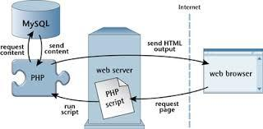

**LANGUAGE SUPPORT**

PHP is free software released under the PHP License .PHP can be deployed on most web servers and also as a standalone shell on almost every operating system and platform ,free of charge.PHP variables, data types and programming constructs variables names start with $ and can include characters,letters,numbers, and _.No other special characters are permitted, are case sensitive, Can’t start with a number.

**WHAT ARE WEB SERVICES?**

**Web services for PHP developers**

* Starting at the beginning: HTTP. HTTP (HyperText Transport Protocol) is the language of the web, the communication channel over which we send our data. ...
* The power of HTTP.
* RPC services.
* Data formats.
* SOAP: A special case of XML-RPC.
* Strategies for debugging.
* Restful services.

**4.3 BACK END-SQL SERVER**

SQL-SERVER database consists of six types of objects, they are

* TABLE
* QUERY
* FORM
* REPORT
* MACRO

**TABLE:**

A database is a collection of data about a specific topic.

**VIEWS OF TABLE:**

We can work with a table in two types,

1. Design View
2. Datasheet View

**DESIGN VIEW**

To build or modify the structure of a table we work in the table design view. We can specify what kind of data will be held.

**DATASHEET VIEW**

To add, edit or analyse the data itself we work in tables datasheet view mode.

**QUERY**

A query is a question that has to be asked in the data. Access gathers data that answers a question from one or more tables. The data that make up the answer is either dynaset (if you edit it) or a snapshot (it cannot be edited). Each time we run a query, we get the latest information in the dynaset. Access either displays the dynaset or snapshot for us to view or perform an action on it, such as deleting or updating.

**MY SQL**

A database management, or DBMS, gives the user access to their data and helps them transform the data into information. Such database management systems include SQL server and MY SQL. These systems allow users to create, update and extract information from their database.

A database is a structured collection of data. Data refers to the characteristics of people, things and events.SQL server stores each data item in its own fields. In SQL Server, the fields relating to a particular person, thing or event are bundled together to form a single complete unit of data, called a record. Each record is made up of a number of fields. No two fields in a record can have the same field name.During a MY SQL Database design project, the analysis of your needs identifies all the fields or attributes of interest. Every table in SQL server has a field or a combination of fields that uniquely identifies each record in the table.The unique identifier is called the Primary key or simply the key.The Primary key distinguish one record from all other in a table.It allows the user and the database system to identify,locate and refer to the one particular record in the database.

**4.4 SQL-SERVER FEATURES**

The OLAP Services feature available in SQL Server version 9.0 is now called SQL Server 2005 Analysis Services. The term OLAP Services has been replaced with the term Analysis Services. Analysis Services also includes a new data mining component. The Repository component available in SQL Server version 9.0 is called Microsoft SQL Server 2005 Meta Data Services. References to the component now use the term Meta data Services. The term repository is used only in reference to the repository is used only in reference to the repository engine within Meta Data services.

**HOW DOES XAMPP SERVER RUN?**

Start the XAMPP program. When started, XAMPP loads itself into your icon tray. The icon is orange with a white bone-like shape in its center. Single-click the icon to expand the Control Panel. Click on the "Start" button next to "Apache" to start your Apache Web server. When Apache is running, the word "Running" will appear next to it, highlighted in green. Also start "MySQL" if your PHP scripts depend on a MySQL database to run.

Place your PHP files in the "HTDocs" folder located under the "XAMPP" folder on your C: drive. The file path is "C:\xampp\htdocs" for your Web server. Make sure your PHP files are saved as such; they must have the ".php" file extension. Open up any Web browser on your desktop and enter "localhost" into the address box. The browser will open a list of files stored under the "HTDocs" folder on your computer. Click on the link to a PHP file and open it to run a script.Create any folders you need to test PHP files in under the "HTDocs" folder. If you create a folder named "scripts," then use the address "localhost/scripts" to open them in your browser.

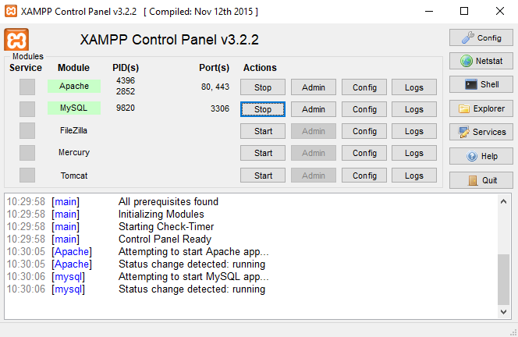

**DATABASE ARCHITECTURE**

Microsoft SQL Server data is stored in databases. The data in a database is organized into the logical components visible to users. A database is also physically implemented as two or more files on disk.

When using a database, you work primarily with the logical components such as tables, views, procedures, and users. The physical implementation of files is largely transparent.

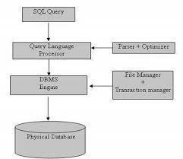

Each SQL Server installation has multiple databases. SQL Server has four system databases (master, model, tempdb, and MSDN) and each SQL Server installation has one or more user databases. Some organizations have only one user database, containing all the data for their organ.

**CHAPTER 5**

**PROJECT DESCRIPTION**

**5.1MODULE**

* Static Pages
* Admin
* Employee

**5.2 MODULE DESCRIPTION**

The Project is a unofficial making Employee Record Management system for a company and has the following modules.

**STATIC PAGES**

This module is divided into different sub-modules.

1. Home
2. About Us
3. Gallery
4. Rules & Regulations
5. Contact Us
6. Terms & Conditions

**5.2.1 GENERAL ENTRY**

* **Home**

In home page the general users are view the company logo, slide images, copyrights information and the company name.

* **About Us**

The general users can see about the company details like company name, when the company are started, who is the owner of the company.

* **Gallery**

In this page the general users can see the images of the company and also videos of the company.

* **Rules & Regulations**

In this page the general users can see the rules and regulations of the company.

* **Contact Us**

In this page the general users are communicate to the company by the social media links provided by the admin.

* **Terms & Conditions**

It shows the terms and conditions of the company to the general users.

**ADMIN**

1. Home
2. Add Employee
3. View Employee
4. Assign Project
5. Project Status
6. Salary Table
7. Employee Leave

Admin will provide login-Access for all the Employees. Administrator will have complete control of the system.

**5.2.2 ADMIN ENTRY**

This module is especially for admin,

* **Home**

In home page the admin can view the employee leaderboard and resets the employees points .

* **Add Employee**

In this page the admin can add employee for the company.

* **View Employee**

The admin can view the added employees in this page. The admin can verify the added employees.

* **Assign Project**

In this page the admin can assign the projects for the employee with due date and project name.

* **Project Status**

In this page the admin can view the status of the projects assigned to the employees and assign the points for the submitted projects.

* **Salary Table**

It shows the salary details of the employee like basic, bonus and total salary.

* **Employee Leave**

It shows the leave applications of the employees . The admin can accept or reject the leave applications.

**EMPLOYEE**

1. Home
2. My Profile
3. My Projects
4. Apply Leave

**5.2.3 EMPLOYEE ENTRY**

This module is especially for employee,

* **Home**

This is the first page the employee views in this page the employee can view the employee leaderboard .

* **My Profile**

In this page employee can view their details and update their profile ( only contact and address ) and also change their password.

* **My Projects**

In this page the employee can view the projects assigned by the admin and submit their projects on this page.

* **Apply Leave**

In this page the employee can apply for a leave of absence and personal reasons .

**5.3 DATAFLOW DIAGRAM**

**5.3.1 ARCHITECTURE**

Use case diagram describes the behavior of the target system from an external point of view. Use cases describe “the meat” of the actual requirements.

* **Use cases:** A use case describes a sequence of actions that provide something of measurable value to an actor and is drawn as a horizontal ellipse.
* **Associations:** Associations between actors and use cases are indicated by solid lines. An association exists whenever an actor is

involved with an interaction described by a use case.

**ADMIN PROCESS:**





DB

**ADMINNN**

**USER PROCESS:**







DB

**USER**

**5.3.2 SEQUENCE DIAGRAM:**

* Sequence diagrams demonstrate the behavior of objects in a use case.
* By describing the objects and the messages they pass.
* The horizontal dimension shows the objects participating in the interaction.
* The vertical arrangement of messages indicates their order.

**EMPLOYEE**

**LOGIN**

**ADMIN**



USERNAME &PASSWORD

INVALID

USERNAME&PASSWORD



LOGIN SUCCESSFULL

PROJECT,SALARY,LEAVE REPORTS OF EMPLOYEE 

**5.3.3** **ACTIVITY DIAGRAM:**

**STORE IN DATABASE**

**LOGIN:**

**LOGIN**

**ADMIN:**

**EMPLOYEE REQUEST**

**ADMIN VIEW**

**5.4.3**

**5.4 DATABASE DESIGN**

**Table Name: alogin**

**Primary Key: User name**

**Purpose: To enter the Admin Login**

|  |  |
| --- | --- |
| **Field Name** | **Data Type** |
| username | Varchar |
| Password | Varchar |

**Table Name: employee**

**Primary Key: customer**

**Purpose : To create a user**

|  |  |
| --- | --- |
| **Field Name** | **Data Type** |
| Id | Varchar |
| firstName | Varchar |
| lastName | Varchar |
| Email | Varchar |
| Password | text |
| Birthday | date |
| Gender | Varchar |
| Contact | Varchar |
| Nid | int |
| Address | Varchar |
| Dept | Varchar |
| Degree | Varchar |
| Pic | text |

**Table Name: employee_leave**

**Primary key: User id**

**Purpose: To apply leave**

|  |  |
| --- | --- |
| **Field Name** | **Data Type** |
| Id | int |
| Token | int |
| Start | date |
| End | date |
| Reason | Varchar |
| Status | Varchar |

**Table Name: project**

**Primary key: Id**

**Purpose: To assign a project**

|  |  |
| --- | --- |
| **Field Name** | **Data Type** |
| Pid | int |
| Eid | int |
| Pname | Varchar |
| Duedate | date |
| Subdate | date |
| Mark | int |
| Status | Varchar |

**Table Name: rank**

**Primary key: Id**

**Purpose: To assign mark for project**

|  |  |
| --- | --- |
| **Field Name** | **Data Type** |
| Eid | int |
| Points | int |

**CHAPTER 6**

**SYSTEM TESTING**

Testing is the process by which developer will generate a set of test data, which gives maximum probability of finding all types of errors that can occur in the software. Testing is an important phase in the software development cycle of any system design. For any software that is newly developed, primary importance has been given to testing of the system. It is the responsibility of the developer to detect all possible errors in the software before handling it to the user or Customer.

**6.1 UNIT TESTING**

As it is a service organization Application, its segregated into 7 different modules and each module has been developed with separate working procedures such that it pertains to the various feasibility tests that need to be followed. The common modules are integrated after individual unit testing with sample values. For example, Registration Unit consists of registration for student and also for Experts. So a common module is developed and its shared for both student and expert with small changes. Thus all 7 different modules were tested with Unit Testing in a specified manner and the errors were rectified

**6.2 ACCEPTANCE TESTING**

Acceptance testing, a testing technique performed to determine whether or not the software system has met the requirement specifications. The main purpose of this test is to evaluate the system's compliance with the business requirements and verify if it is has met the required criteria for delivery to end users.

**TYPE OF ACCEPTANCE TESTING**

* User acceptance Testing
* Business acceptance Testing
* Alpha Testing
* Beta Testing

**6.3 TEST CASES**

A test case is a document, which has a set of test data, preconditions, expected results and postconditions, developed for a particular test scenario in order to verify compliance against a specific requirement.

Test Case acts as the starting point for the test execution, and after applying a set of input values, the application has a definitive outcome and leaves the system at some end point or also known as execution postcondition.

**CHAPTER 7**

**CONCLUSION & FUTURE ENHANCEMENTS**

**7.1 CONCLUSION**

Finally, the system is used to store the employee records using admin using localhost. The main idea of the project is to automate all the work of the employee .

* View employee request
* Work through online
* Reports submit through online

**7.2 FUTURE ENHANCEMENTS**

In this project, many future plans may be implemented to this process. However future thinking has expanded hugely in scope and substance. This system can be expanded to be more user friendly & Secured. Some of them are listed below.

* In future it can developed as an application.
* It will be made more user friendly than now.
* There will be increased security and privacy.

**CHAPTER 8**

**APPENDIX**

**8.1 SCREEN SHOTS**

**HOME PAGE**

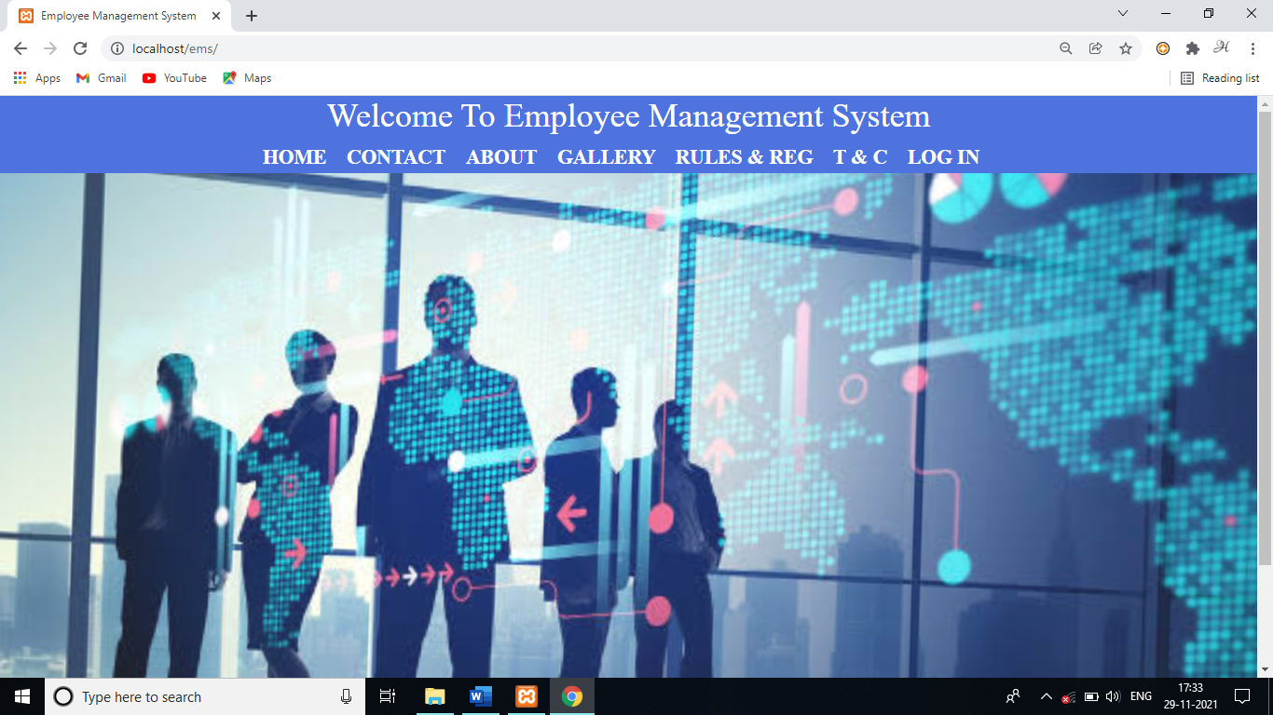

**ADMIN PAGE**

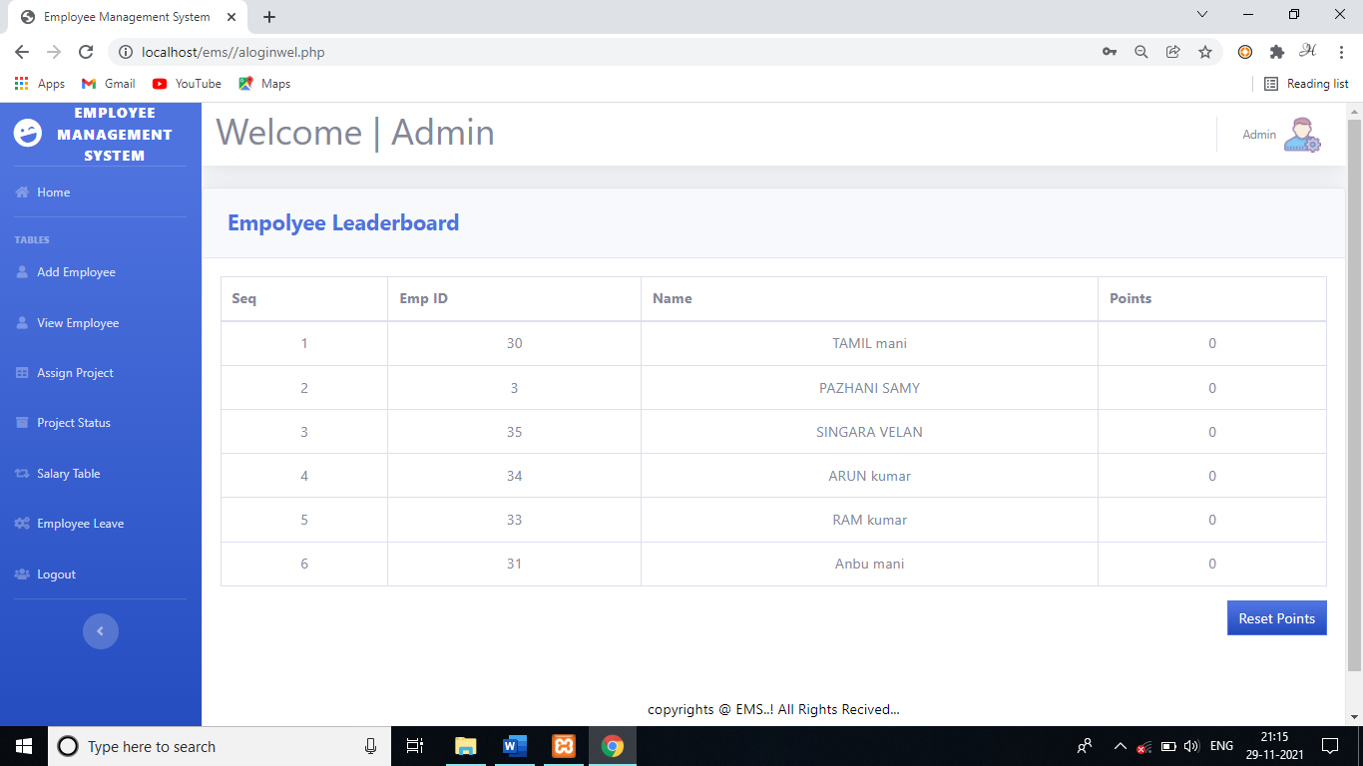

**UESR PAGE**

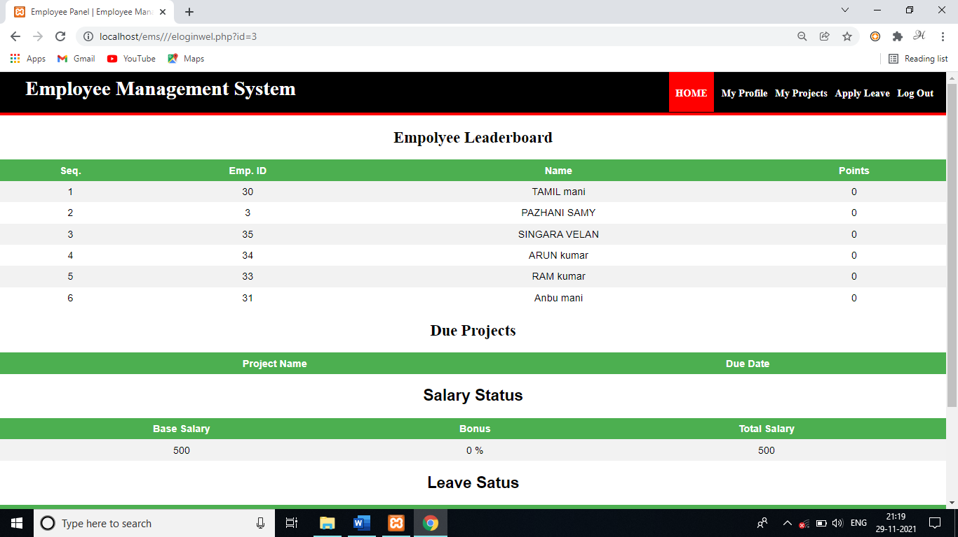

**GALLERY**

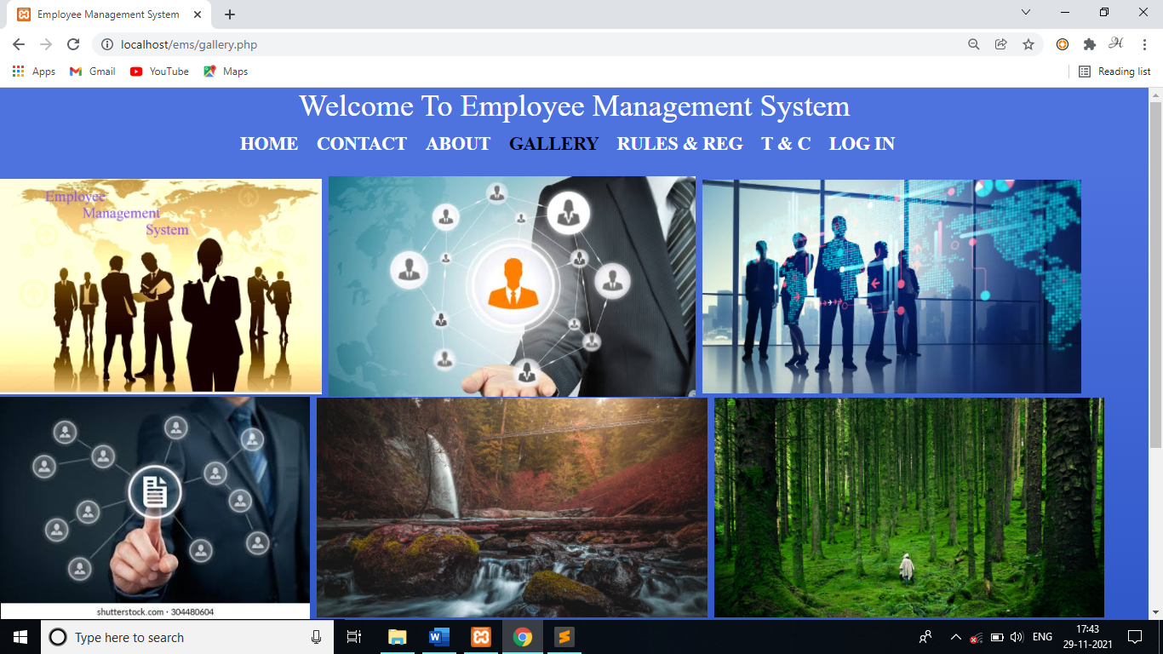

**VIEW EMPLOYEE**

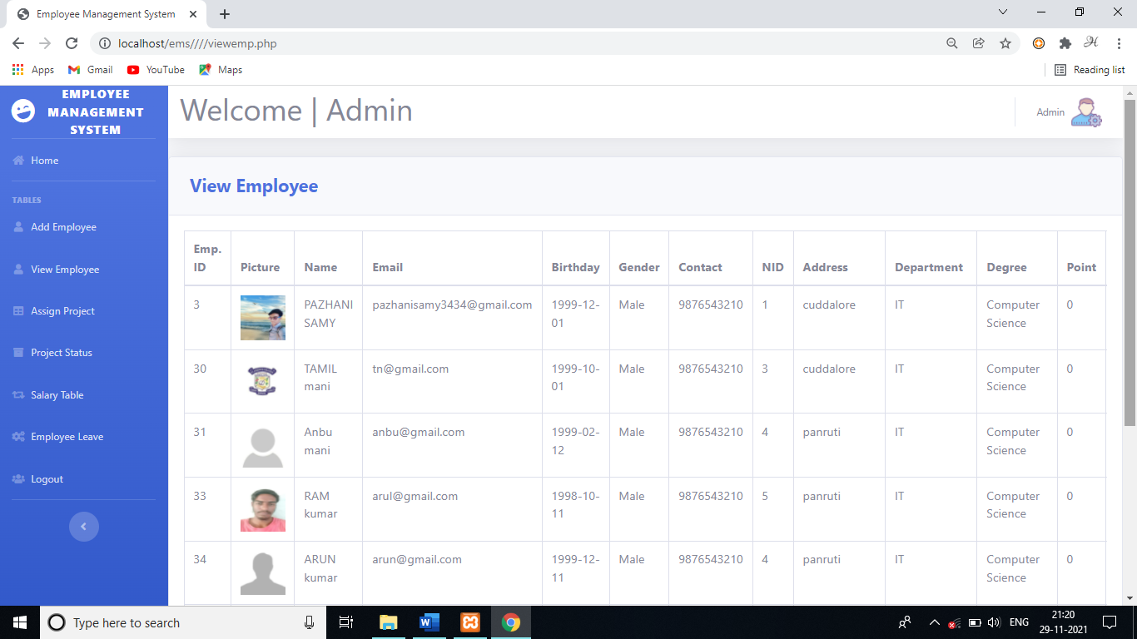

**8.2 SOURCE CODE**

**ABOUTUS.PHP**

<!DOCTYPE html>

<html>

<head>

<title>Employee Management System</title>

<link

href="https://fonts.googleapis.com/css?family=Nunito:200,200i,300,300i,400,400i,600,600i,700,700i,800,800i,900,900i"

rel="stylesheet">

<link href="css/sb-admin-2.min.css" rel="stylesheet">

</head>

<body class="bg-gradient-primary" >

<header>

<nav><center><font face="times new roman" color="white" size="5">

<h1>Welcome To Employee Management System</h1>

<a class="homered" href="index.php"><b><font color="white">HOME</font></b></a>

&nbsp;&nbsp;

<a href="contact.php"><b><font color="white">CONTACT</font></b></a>

&nbsp;&nbsp;

<a href="aboutus.php"><b><font color="black">ABOUT </font></b></a>

&nbsp;&nbsp;

<a href="gallery.php"><b><font color="white">GALLERY </font></b></a>

&nbsp;&nbsp;

<a href="rules.php"><b><font color="white">RULES & REG </font></b></a>

&nbsp;&nbsp;

<a href="terms.php"><b><font color="white">T & C </font></b></a>

&nbsp;&nbsp;

<a href="elogin.php"><b><font color="white">LOG IN</font></b></a>

&nbsp;&nbsp;

</font>

</center>

</nav>

</header><br><center>

<p><b><font color="white" size="5">During this covid19 pandemic situation few companies are closed and many companies are established the work from home .

To make all details of the employees of an company to handle the record easily and also access the record from anywhere and anytime .

To promote an automated system to manage the employee details and encourage the user to access the website easily and to manage things more efficiently.

To help employee to avoid manual work and reduce workload . This online employee management system is more useful to the work from home employees through online features.I developed this Website for the EMS company with the coprrights 2021 . <br><br><br><br><marquee>To Know More Details About Us By the Following Social Media Links .</marquee></font></p><br>

<center> <font color="white" size="5">

<img src="images/facebook.png" height="1%" width="3%">

emsonfacebook &nbsp;

<img src="images/twiter.png" height="1%" width="3%">

@emsontwitter &nbsp;

<img src="images/googleplus.png" height="1%" width="3%"> emsongoogle@gmail.com &nbsp;

<img src="images/linkedin.png" height="1%" width="3%">

emsonlinkedin.in &nbsp;

</font></center>

</b>

</center>

<center>

<div>

<h1><font face="times new roman" color="white" size="3">

copyrights @ EMS..! All Rights Recived...

</font>

</h1></div></center>

</body>

</html>

**INDEX.PHP**

<!DOCTYPE html>

<html>

<head>

<title>Employee Management System</title>

<link

href="https://fonts.googleapis.com/css?family=Nunito:200,200i,300,300i,400,400i,600,600i,700,700i,800,800i,900,900i"

rel="stylesheet">

<link href="css/sb-admin-2.min.css" rel="stylesheet">

<meta charset="utf-8">

<meta name="viewport" content="width=device-width, initial-scale=1.0">

<link rel="stylesheet" type="text/css" href="s.css">

</head>

<body class="bg-gradient-primary" >

<header>

<nav><center><font face="times new roman" color="white" size="5">

<h1>Welcome To Employee Management System</h1>

<a href="index.php"><b><font color="black">HOME</font></b></a>

&nbsp;&nbsp;

<a href="contact.php"><b><font color="white">CONTACT</font></b></a>

&nbsp;&nbsp;

<a href="aboutus.php"><b><font color="white">ABOUT </font></b></a>

&nbsp;&nbsp;

<a href="gallery.php"><b><font color="white">GALLERY </font></b></a>

&nbsp;&nbsp;

<a href="rules.php"><b><font color="white">RULES & REG </font></b></a>

&nbsp;&nbsp;

<a href="terms.php"><b><font color="white">T & C </font></b></a>

&nbsp;&nbsp;

<a href="elogin.php"><b><font color="white">LOG IN</font></b></a>

&nbsp;&nbsp;

</font>

</center>

</nav>

</header>

</div>

<div class="slides slowFade">

<div class="slide">

<img src="images/1.jpeg" alt="img"/>

</div>

<div class="slide">

<img src="images/2.jpeg" alt="img"/>

</div>

<div class="slide">

<img src="images/3.jpeg" alt="img"/>

</div>

<div class="slide">

<img src="images/ems.jpg" alt="img"/>

</div>

</div>

<center>

<h1><font face="times new roman" color="white" size="3">

copyrights @ EMS..! All Rights Recived...

</font>

</h1></center>

</body>

</html>

**CONTACT.PHP**

<!DOCTYPE html>

<html>

<head>

<title>Employee Management System</title>

<link

href="https://fonts.googleapis.com/css?family=Nunito:200,200i,300,300i,400,400i,600,600i,700,700i,800,800i,900,900i"

rel="stylesheet">

<link href="css/sb-admin-2.min.css" rel="stylesheet">

</head>

<body class="bg-gradient-primary" >

<header>

<nav><center><font face="times new roman" color="white" size="5">

<h1>Welcome To Employee Management System</h1>

<a href="index.php"><b><font color="white">HOME</font></b></a>

&nbsp;&nbsp;

<a href="contact.php"><b><font color="black">CONTACT</font></b></a>

&nbsp;&nbsp;

<a href="aboutus.php"><b><font color="white">ABOUT </font></b></a>

&nbsp;&nbsp;

<a href="gallery.php"><b><font color="white">GALLERY </font></b></a>

&nbsp;&nbsp;

<a href="rules.php"><b><font color="white">RULES & REG </font></b></a>

&nbsp;&nbsp;

<a href="terms.php"><b><font color="white">T & C </font></b></a>

&nbsp;&nbsp;

<a href="elogin.php"><b><font color="white">LOG IN</font></b></a>

&nbsp;&nbsp;

</font>

</center>

</nav>

</header><br><center>

<img src="images\1.jpeg" width="40%"><br>

<marquee><p><font size="5" color="white"><b>CONTACT US THROUGH THE SOCIAL MEDIA LINKS BELOW</b></font></p></marquee></center>

<center> <font color="white" size="5">

<img src="images/facebook.png" height="1%" width="3%">

emsonfacebook &nbsp;

<img src="images/twiter.png" height="1%" width="3%">

@emsontwitter &nbsp;

<img src="images/googleplus.png" height="1%" width="3%"> emsongoogle@gmail.com &nbsp;

<img src="images/linkedin.png" height="1%" width="3%">

emsonlinkedin.in &nbsp;

</font></center>

<center>

<div>

<h1><font face="times new roman" color="white" size="3">

copyrights @ EMS..! All Rights Recived...

</font>

</h1></div></center>

</body>

</html>

**ALOGINWEL.PHP**

<?php

include 'sidebar.php';

?><?php

require_once ('process/dbh.php');

$sql = "SELECT id, firstName, lastName, points FROM employee, rank WHERE rank.eid = employee.id order by rank.points desc";

$result = mysqli_query($conn, $sql);

?>

<div class="card shadow mb-4">

<div class="card-header py-3">

<h4 class="m-2 font-weight-bold text-primary">Empolyee Leaderboard&nbsp;</h4>

</div>

<div class="card-body">

<div class="table-responsive">

<table class="table table-bordered" id="dataTable" width="100%" cellspacing="0">

<thead>

<tr>

<th>Seq</th>

<th>Emp ID</th>

<th>Name</th>

<th>Points</th>

</tr>

</thead>

<tbody>

<?php

$seq = 1;

while ($employee = mysqli_fetch_assoc($result)) {

echo "<tr>";

echo "<td><center>".$seq."</center></td>";

echo "<td><center>".$employee['id']."<center></td>";

echo "<td><center>".$employee['firstName']." ".$employee['lastName']."</center></td>";

echo "<td><center>".$employee['points']."</center></td>";

$seq+=1;

}

?>

</tbody>

</table>

<div align="Right">

<a href="reset.php" data-toggle="modal" type="button" class="btn btn-primary bg-gradient-primary" style="border-radius: 0px;">Reset Points</a>

</div>

<br><br><center>

<div>

<h1><font color="black" size="3">

copyrights @ EMS..! All Rights Recived...

</font>

</h1></div></center>

</div>

**ELOGINWEL.PHP**

<?php

$id = (isset($_GET['id']) ? $_GET['id'] : '');

require_once ('process/dbh.php');

$sql1 = "SELECT * FROM `employee` where id = '$id'";

$result1 = mysqli_query($conn, $sql1);

$employeen = mysqli_fetch_array($result1);

$empName = ($employeen['firstName']);

$sql = "SELECT id, firstName, lastName, points FROM employee, rank WHERE rank.eid = employee.id order by rank.points desc";

$sql1 = "SELECT `pname`, `duedate` FROM `project` WHERE eid = $id and status = 'Due'";

$sql2 = "Select * From employee, employee_leave Where employee.id = $id and employee_leave.id = $id order by employee_leave.token";

$sql3 = "SELECT * FROM `salary` WHERE id = $id";

$result = mysqli_query($conn, $sql);

$result1 = mysqli_query($conn, $sql1);

$result2 = mysqli_query($conn, $sql2);

$result3 = mysqli_query($conn, $sql3);

?>

<html>

<head>

<title>Employee Panel | Employee Management System</title>

<link rel="stylesheet" type="text/css" href="styleemplogin.css">

<link href="https://fonts.googleapis.com/css?family=Lobster|Montserrat" rel="stylesheet">

</head>

<body>

<header>

<nav>

<h1 > <font face= "Times New Roman"> <b>Employee Management System</b></font></h1>

<ul id="navli">

<li><a class="homered" href="eloginwel.php?id=<?php echo $id?>"><font face="times new Roman"><b>HOME</a></b></font></li>

<li><a class="homeblack" href="myprofile.php?id=<?php echo $id?>"><font face="times new Roman"><b>My Profile</a></b></font></li>

<li><a class="homeblack" href="empproject.php?id=<?php echo $id?>"><font face="times new Roman"><b>My Projects</a></b></font></li>

<li><a class="homeblack" href="applyleave.php?id=<?php echo $id?>"><font face="times new Roman"><b>Apply Leave</a></b></font></li>

<li><a class="homeblack" href="elogin.php"><font face="times new Roman"><b>Log Out</a></b></font></li>

</ul>

</nav>

</header>

<div class="divider"></div>

<div id="divimg">

<div>

<h2 style="font-family: 'Montserrat', times new roman; font-size: 25px; text-align: center;">Empolyee Leaderboard </h2>

<table>

<tr bgcolor="#000">

<th align = "center">Seq.</th>

<th align = "center">Emp. ID</th>

<th align = "center">Name</th>

<th align = "center">Points</th>

</tr>

<?php

$seq = 1;

while ($employee = mysqli_fetch_assoc($result)) {

echo "<tr>";

echo "<td>".$seq."</td>";

echo "<td>".$employee['id']."</td>";

echo "<td>".$employee['firstName']." ".$employee['lastName']."</td>";

echo "<td>".$employee['points']."</td>";

$seq+=1;

}

?>

</table>

<h2 style="font-family: 'times new roman', sans-serif; font-size: 25px; text-align: center;">Due Projects</h2>

<table>

<tr>

<th align = "center">Project Name</th>

<th align = "center">Due Date</th>

</tr>

<?php

while ($employee1 = mysqli_fetch_assoc($result1)) {

echo "<tr>";

echo "<td>".$employee1['pname']."</td>";

echo "<td>".$employee1['duedate']."</td>";

}

?>

</table>

<h2 style="font-family: 'Montserrat', sans-serif; font-size: 25px; text-align: center;">Salary Status</h2>

<table>

<tr>

<th align = "center">Base Salary</th>

<th align = "center">Bonus</th>

<th align = "center">Total Salary</th>

</tr>

<?php

while ($employee = mysqli_fetch_assoc($result3)) {

echo "<tr>";

echo "<td>".$employee['base']."</td>";

echo "<td>".$employee['bonus']." %</td>";

echo "<td>".$employee['total']."</td>";

}

?>

</table>

<h2 style="font-family: 'Montserrat', sans-serif; font-size: 25px; text-align: center;">Leave Satus</h2>

<table>

<tr>

<th align = "center">Start Date</th>

<th align = "center">End Date</th>

<th align = "center">Total Days</th>

<th align = "center">Reason</th>

<th align = "center">Status</th>

</tr>

<?php

while ($employee = mysqli_fetch_assoc($result2)) {

$date1 = new DateTime($employee['start']);

$date2 = new DateTime($employee['end']);

$interval = $date1->diff($date2);

$interval = $date1->diff($date2);

echo "<tr>";

echo "<td>".$employee['start']."</td>";

echo "<td>".$employee['end']."</td>";

echo "<td>".$interval->days."</td>";

echo "<td>".$employee['reason']."</td>";

echo "<td>".$employee['status']."</td>";

}

?>

</table>

<br><br>

<center>

<div>

<h1><font size="3">

copyrights @ EMS..! All Rights Recived...

</font>

</h1></div></center>

</div>

</body>

</html>

**ADDEMP.PHP**

<?php

include 'sidebar.php';

?>

<center><div class="card shadow mb-4 col-xs-12 col-md-8 border-bottom-primary">

<div class="card-header py-3">

<h4 class="m-2 font-weight-bold text-primary">Add Employee</h4>

</div>

<a href="addemp.php" type="button" class="btn btn-primary bg-gradient-primary">Fill The Form</a>

<div class="card-body">

<div class="table-responsive">

<form action="process/addempprocess.php" method="POST">

<div class="form-group">

<input class="form-control" placeholder="First Name" name="firstName" required>

</div>

<div class="form-group">

<input class="form-control" placeholder="Last Name" name="lastName" required>

</div>

<div class="form-group">

<input class="form-control" placeholder="Email" name="email" required>

</div>

<div class="form-group">

<input type="date" placeholder="BIRTHDATE" name="birthday" value="yyyy-MM-dd" class="form-control" />

</div>

<div class="form-group">

<select class="form-control" placeholder="Gender" name="gender" required><option disabled="disabled" selected="selected">GENDER</option>

<option value="Male">Male</option>

<option value="Female">Female</option>

<option value="Other">Other</option></select>

</div>

<div class="form-group">

<input class="form-control" placeholder="Contact Number" name="contact" required>

</div>

<div class="form-group">

<input class="form-control" placeholder="NID" name="nid" required>

</div>

<div class="form-group">

<input class="form-control" placeholder="Address" name="address" required>

</div>

<div class="form-group">

<input class="form-control" placeholder="Department" name="dept" required>

</div>

<div class="form-group">

<input class="form-control" placeholder="Degree" name="degree" required>

</div>

<div class="form-group">

<input class="form-control" placeholder="Salary" name="salary">

</div>

<div class="form-group">

<input class="form-control"type="file" placeholder="file" name="file">

</div>

<hr>

<button type="submit" class="btn btn-success btn-block"><i class="fa fa-check fa-fw"></i>Save</button>

<button type="reset" class="btn btn-danger btn-block"><i class="fa fa-times fa-fw"></i>Reset</button>

</form>

</div>

</div>

</div></center>

<center>

<div>

<h1><font size="3">

copyrights @ EMS..! All Rights Recived...

</font>

</h1></div></center>

</div>

**VIEWEMP.PHP**

<?php

include 'sidebar.php';

?>

<?php

require_once ('process/dbh.php');

$sql = "SELECT * from `employee` , `rank` WHERE employee.id = rank.eid";

$result = mysqli_query($conn, $sql);

?>

<div class="card shadow mb-4">

<div class="card-header py-3">

<h4 class="m-2 font-weight-bold text-primary">View Employee&nbsp;</h4>

</div>

<div class="card-body">

<div class="table-responsive">

<table class="table table-bordered" id="dataTable" width="100%" cellspacing="0">

<thead>

<tr>

<th align = "center">Emp. ID</th>

<th align = "center">Picture</th>

<th align = "center">Name</th>

<th align = "center">Email</th>

<th align = "center">Birthday</th>

<th align = "center">Gender</th>

<th align = "center">Contact</th>

<th align = "center">NID</th>

<th align = "center">Address</th>

<th align = "center">Department</th>

<th align = "center">Degree</th>

<th align = "center">Point</th>

<th align = "center">Options</th>

</tr>

</thead>

<tbody>

<?php

while ($employee = mysqli_fetch_assoc($result)) {

echo "<tr>";

echo "<td>".$employee['id']."</td>";

echo "<td><img src='process/".$employee['pic']."' height = 60px width = 60px></td>";

echo "<td>".$employee['firstName']." ".$employee['lastName']."</td>";

echo "<td>".$employee['email']."</td>";

echo "<td>".$employee['birthday']."</td>";

echo "<td>".$employee['gender']."</td>";

echo "<td>".$employee['contact']."</td>";

echo "<td>".$employee['nid']."</td>";

echo "<td>".$employee['address']."</td>";

echo "<td>".$employee['dept']."</td>";

echo "<td>".$employee['degree']."</td>";

echo "<td>".$employee['points']."</td>";

echo "<td><a href=\"edit.php?id=$employee[id]\">Edit</a> | <a href=\"delete.php?id=$employee[id]\" onClick=\"return confirm('Are you sure you want to delete?')\">Delete</a></td>";

}

?>

</tbody>

</table>

<br><br><center>

<div>

<h1><font color="black" size="3">

copyrights @ EMS..! All Rights Recived...

</font>

</h1></div></center>

</div>

**ASSIGN.PHP**

<?php

include 'sidebar.php';

?>

<center><div class="card shadow mb-4 col-xs-12 col-md-8 border-bottom-primary">

<div class="card-header py-3">

<h4 class="m-2 font-weight-bold text-primary">Assign Project</h4>

</div>

<a href="assign.php" type="button" class="btn btn-primary bg-gradient-primary">Assign</a>

<div class="card-body">

<div class="table-responsive">

<form action="process/assignp.php" method="POST">

<div class="form-group">

<input class="form-control" placeholder="Employee ID" name="eid" required>

</div>

<div class="form-group">

<input class="form-control" placeholder="Project Name" name="pname" required>

</div>

<div class="form-group">

<input type="date" placeholder="date" name="duedate" value="yyyy-MM-dd" class="form-control" />

<hr>

<button type="submit" class="btn btn-success btn-block"><i class="fa fa-check fa-fw"></i>Assign</button>

<button type="reset" class="btn btn-danger btn-block"><i class="fa fa-times fa-fw"></i>Reset</button>

</form>

</div>

</div>

</div></center>

<center>

<div>

<h1><font size="3">

copyrights @ EMS..! All Rights Recived...

</font>

</h1></div></center>

</div>

**APPLYLEAVE.PHP**

<?php

$id = (isset($_GET['id']) ? $_GET['id'] : '');

require_once ('process/dbh.php');

$sql = "SELECT * FROM `employee` where id = '$id'";

$result = mysqli_query($conn, $sql);

$employee = mysqli_fetch_array($result);

$empName = ($employee['firstName']);

?>

<html>

<head>

<title>Apply Leave | Employee Panel | Employee Management System</title>

<link rel="stylesheet" type="text/css" href="styleapply.css">

</head>

<body bgcolor="#F0FFFF">

<header>

<nav>

<h1>Employee Management System</h1>

<ul id="navli">

<li><a class="homeblack" href="eloginwel.php?id=<?php echo $id?>">HOME</a></li>

<li><a class="homeblack" href="myprofile.php?id=<?php echo $id?>">My Profile</a></li>

<li><a class="homeblack" href="empproject.php?id=<?php echo $id?>">My Projects</a></li>

<li><a class="homered" href="applyleave.php?id=<?php echo $id?>">Apply Leave</a></li>

<li><a class="homeblack" href="elogin.php">Log Out</a></li>

</ul>

</nav>

</header>

<div class="divider"></div>

<div class="page-wrapper bg-blue p-t-100 p-b-100 font-robo">

<div class="wrapper wrapper--w680">

<div class="card card-1">

<div class="card-heading"></div>

<div class="card-body">

<h2 class="title">Apply Leave Form</h2>

<form action="process/applyleaveprocess.php?id=<?php echo $id?>" method="POST">

<div class="input-group">

<input class="input--style-1" type="text" placeholder="Reason" name="reason">

</div>

<div class="row row-space">

<div class="col-2">

<p>Start Date</p>

<div class="input-group">

<input class="input--style-1" type="date" placeholder="start" name="start">

</div>

</div>

<div class="col-2">

<p>End Date</p>

<div class="input-group">

<input class="input--style-1" type="date" placeholder="end" name="end">

</div>

</div>

</div>

<div class="p-t-20">

<button class="btn btn--radius btn--green" type="submit">Submit</button>

</div>

</form>

</div>

</div>

</div>

</div>

<table>

<tr>

<th align = "center">Emp. ID</th>

<th align = "center">Name</th>

<th align = "center">Start Date</th>

<th align = "center">End Date</th>

<th align = "center">Total Days</th>

<th align = "center">Reason</th>

<th align = "center">Status</th>

</tr>

<?php

$sql = "Select employee.id, employee.firstName, employee.lastName, employee_leave.start, employee_leave.end, employee_leave.reason, employee_leave.status From employee, employee_leave Where employee.id = $id and employee_leave.id = $id order by employee_leave.token";

$result = mysqli_query($conn, $sql);

while ($employee = mysqli_fetch_assoc($result)) {

$date1 = new DateTime($employee['start']);

$date2 = new DateTime($employee['end']);

$interval = $date1->diff($date2);

$interval = $date1->diff($date2);

echo "<tr>";

echo "<td>".$employee['id']."</td>";

echo "<td>".$employee['firstName']." ".$employee['lastName']."</td>";

echo "<td>".$employee['start']."</td>";

echo "<td>".$employee['end']."</td>";

echo "<td>".$interval->days."</td>";

echo "<td>".$employee['reason']."</td>";

echo "<td>".$employee['status']."</td>";

}

?>

</table>

<center>

<div>

<h1><font size="3">

copyrights @ EMS..! All Rights Recived...

</font>

</h1></div></center>

</div>

</body>

</html>

**MYPROFILE.PHP**

<?php

require_once ('process/dbh.php');

$sql = "SELECT * FROM `employee` WHERE 1";

$result = mysqli_query($conn, $sql);

$id = (isset($_GET['id']) ? $_GET['id'] : '');

$sql = "SELECT * from `employee` WHERE id=$id";

$sql2 = "SELECT total from `salary` WHERE id = $id";

$result = mysqli_query($conn, $sql);

$result2 = mysqli_query($conn , $sql2);

$salary = mysqli_fetch_array($result2);

$empS = ($salary['total']);

if($result){

while($res = mysqli_fetch_assoc($result)){

$firstname = $res['firstName'];

$lastname = $res['lastName'];

$email = $res['email'];

$contact = $res['contact'];

$address = $res['address'];

$gender = $res['gender'];

$birthday = $res['birthday'];

$nid = $res['nid'];

$dept = $res['dept'];

$degree = $res['degree'];

$pic = $res['pic'];

}

}

?>

<html>

<head>

<title>My Profile | Employee Management System</title>

<link rel="stylesheet" type="text/css" href="styleapply.css">

</head>

<body>

<header>

<nav>

<h1>Employee Management System</h1>

<ul id="navli">

<li><a class="homeblack" href="eloginwel.php?id=<?php echo $id?>">HOME</a></li>

<li><a class="homered" href="myprofile.php?id=<?php echo $id?>">My Profile</a></li>

<li><a class="homeblack" href="empproject.php?id=<?php echo $id?>">My Projects</a></li>

<li><a class="homeblack" href="applyleave.php?id=<?php echo $id?>">Apply Leave</a></li>

<li><a class="homeblack" href="elogin.php">Log Out</a></li>

</ul>

</nav>

</header>

<div class="divider"></div>

<div class="page-wrapper bg-blue p-t-100 p-b-100 font-robo">

<div class="wrapper wrapper--w680">

<div class="card card-1">

<div class="card-heading"></div>

<div class="card-body">

<center> <h2 class="title">My Info</h2></center>

<form method="POST" action="myprofileup.php?id=<?php echo $id?>" >

<div align="center">

<img src="process/<?php echo $pic;?>" height = 80px width = 80px>

</div><br>

<div class="row row-space">

<div class="col-2">

<p>First Name</p>

<div class="input-group">

<input class="input--style-1" name="firstName" value="<?php echo $firstname;?>" readonly >

</div>

</div>

<div class="col-2">

<p>Last Name</p>

<div class="input-group">

<input class="input--style-1" name="lastName" value="<?php echo $lastname;?>" readonly>

</div>

</div>

<div class="col-2">

<p>Email-ID</p>

<div class="input-group">

<input class="input--style-1" name="email" value="<?php echo $email;?>" readonly>

</div>

</div>

<div class="col-2">

<p>Date Of Birth</p>

<div class="input-group">

<input class="input--style-1" type="text" name="birthday" value="<?php echo $birthday;?>" readonly>

</div>

</div>

<div class="col-2">

<p>Gender</p>

<div class="input-group">

<input class="input--style-1" type="text" name="gender" value="<?php echo $gender;?>" readonly>

</div>

</div>

<div class="col-2">

<p>Contact Number</p>

<div class="input-group">

<input class="input--style-1" type="number" name="contact" value="<?php echo $contact;?>" readonly>

</div>

</div>

<div class="col-2">

<p>NID</p>

<div class="input-group">

<input class="input--style-1" type="number" name="nid" value="<?php echo $nid;?>" readonly>

</div>

</div>

<div class="col-2">

<p>Address</p>

<div class="input-group">

<input class="input--style-1" type="text" name="address" value="<?php echo $address;?>" readonly>

</div>

</div>

<div class="col-2">

<p>Department</p>

<div class="input-group">

<input class="input--style-1" type="text" name="dept" value="<?php echo $dept;?>" readonly>

</div>

</div>

<div class="col-2">

<p>Degree</p>

<div class="input-group">

<input class="input--style-1" type="text" name="degree" value="<?php echo $degree;?>" readonly>

</div>

</div>

<div class="col-2">

<p>Salary</p>

<div class="input-group">

<input class="input--style-1" type="text" name="degree" value="<?php echo $empS;?>" readonly>

</div>

</div>

<div >

<div class="input-group">

<input class="input--style-1" type="hidden" name="id" id="textField" value="<?php echo $id;?>" required>

</div>

</div>

<div aliclass="input-group">

<div class="p-t-20">

<button type="submit" name="send" class="btn btn--radius btn--green"><i class="fa fa-check fa-fw"></i>Update Info</button>

</div>

</div>

</div>

</form>

<br><br>

<center>

<div>

<h1><font size="3">

copyrights @ EMS..! All Rights Recived...

</font>

</h1></div></center>

</div>

</body>

</html>